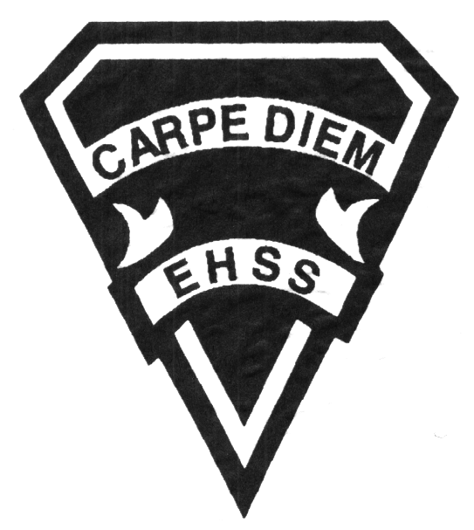

**2019/2020**

### Canadian History in the Twentieth Century (ESL)

**Social Sciences Department**

## Earl Haig

SecondarySchool

# **CHC2D8**

**Evaluation Profile & Outline**

**Course Description/Rationale/Overview:** This course is designed to enable ESL students at Level C to explore key points in Canada’s history during the Twentieth Century. The development of Canada as nation is emphasized by examining Canada’s participation in the two World Wars, its development in the 1920’s, the hardships of the Depression and issues in the post-war era.

**Class Requirements:** Students should have materials specified by the subject teacher at the beginning of the year.

The textbook for this course is Experience History. Students will be issued this book at the beginning of the course. The replacement cost for this textbook $ 120.00.

**Assessment and Evaluation Strategies**

Students will also be expected to complete assessment activities of a formative nature in order to learn and to practice the specific expectations that will compose the summative evaluations. Examples of formative assessment may include homework checks, quizzes, peer assessment, presentations, reflection writing, role-play scenarios and observation.

Each unit or strand of the course will be evaluated using summative evaluations. Examples of summative evaluations are tests, case studies, interviews, reports, presentations, seminars, debates, research and other writing assignments.

**Late and/or Missed Evaluation**

##### Late Assignments

For each assignment, the teacher will inform students of the due date and the ultimate deadline. The ultimate deadline is the last opportunity for students to submit an assignment for evaluation. If an assignment is submitted after the ultimate deadline, it will not be evaluated and a mark of zero will be assigned. In certain circumstances, the student may be granted an extension of the ultimate deadline at the teacher’s discretion, only if an arrangement has been made with the teacher beforehand.

**Missed Tests**

It is the student’s responsibility to make arrangements, ahead of time, for any tests/quizzes that are missed. If a student misses a test/quiz for an unforeseen reason such as illness, the student must bring a note signed by a parent or guardian and be prepared to write the test/quiz immediately upon return to school at a time determined by the teacher. Once the tests/quizzes have been evaluated and returned, students will not be able to make up a missed test - a mark of zero will be assigned.

**Subject-Specific/Department Information**

Teachers in the Social Sciences Department can be reached at (416) 395-3210, ext. 20075 or 20085. Parents wishing to meet with a teacher are requested to make an appointment with the teacher prior to coming to the school.

**Learning Skills\***

**Responsibility** – meets deadlines; takes responsibility for own behaviour

**Organization** – establishes priorities and manages time; uses information, technology and resources top complete tasks time management

**Independent Work** – follows instruction with minimal supervision; uses class time appropriately to complete tasks

**Collaboration** – accepts an equitable share of work in a group; builds healthy peer relationships; works with others to achieve group goals

**Initiative** – looks for opportunities for learning; demonstrates curiosity; approaches new tasks with a positive attitude

**Self-regulation** – sets own goals and monitors own progress; seeks assistance with needed; makes an effort with responding to challenges

###### Final Mark

The final mark for this course will be determined based upon an accumulation of marks from unit summative activities and from a final summative evaluation

**Year’s Work 70%**

This is a culmination of evaluations that have been completed throughout the year. It may include tests, presentations, research, or topic specific assignments.

**Final Summative Evaluation 30%**

This will be completed during the final six weeks of the course and may include a variety of summative activities including an exam, project presentation, seminar or a writing assignment.

**Achievement Categories and Weighting**

* **Knowledge / Understanding – 35%**

Knowledge of facts and terms; understanding of concepts, principles, guidelines and strategies; understanding of relationships among concepts.

* **Application – 20%**

Synthesizing knowledge and understanding into new and familiar contexts as well as making connections between various contexts.

* **Thinking Inquiry – 25%**

Formulating questions; planning, selecting strategies and resources; analyzing and interpreting information, and forming conclusions.

* **Communication – 20%**

Communication of information and ideas, communication for different audiences, use of various forms of communication.

*From: Ontario Ministry of Education. *Growing Success: Assessment, Evaluation, and Reporting in Ontario Schools*. Toronto: Ministry of Education, 2010, 11.



**2019/2020**

### Canadian History in the Twentieth Century (ESL)

**Social Sciences Department**

## Earl Haig

SecondarySchool

# **Course Code**

**Evaluation Profile & Outline**

**Course Outline:**

**Unit 1: Overview of Canadian History**

In this unit, students examine selected events in Canada’s History from Confederation to 1914. Examination of these events will provide a basis for students, who may be new to Canada, to understand events leading up to Canada’s involvement in World War I.

**Unit 2: Canada and World War I**

This unit examines Canada’s reasons for entering World War I and the contributions made by Canadians on the battlefield and at home. It also reflects on how Canada changed as a result of this participation**.**

**Unit 3: The 1920s and 1930s**

This unit examines the years of turmoil between the two World Wars highlighting the post-war problems and the stock market collapse in the late 1920’s It focuses on how individuals and governments responded to the many social, economic and political challenges that Canadians faced.

**Unit 4: Canada and World War II**

This unit examines the events in Europe that led to World War II and our very significant role during that war. A significant part of this unit focuses on the transformation of the country from a former British colony into a wealthy, independent nation with a role to play on the international stage.

**Unit 5: Canada in the Post-War Era**

This unit looks at the years 1945-1969 with an emphasis on international themes global trade, peacekeeping, continental defense, human rights) and the revival of Quebec nationalism.